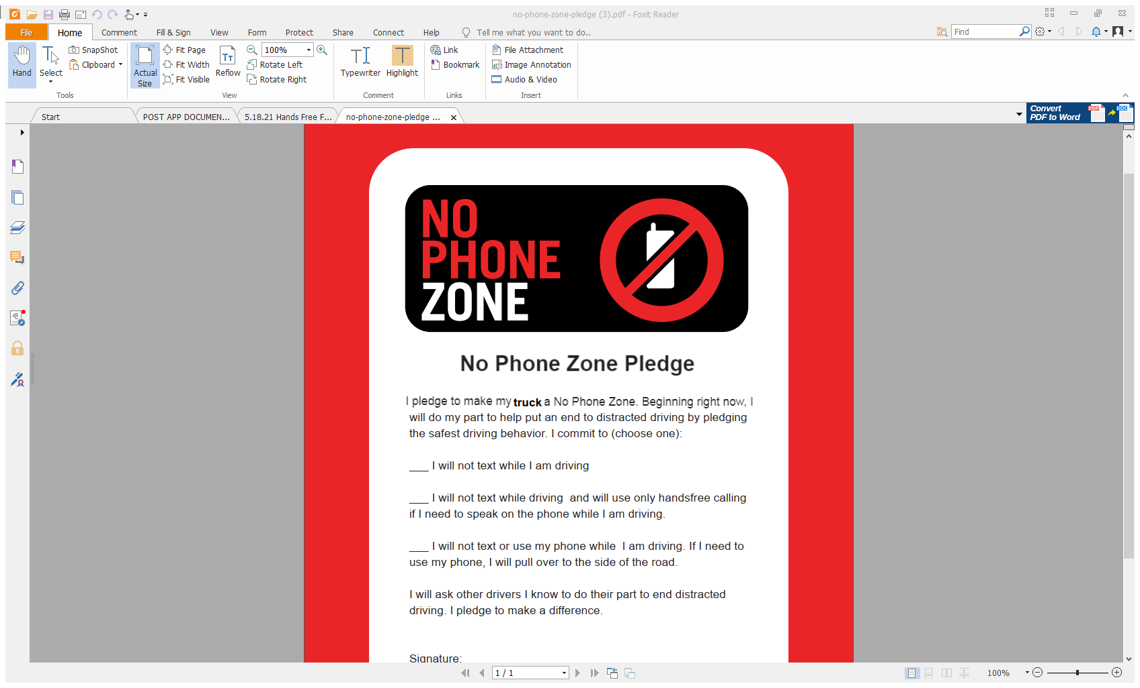

will do my part to help put an end to distracted driving by pledging

the safest driving behavior. I commit to: (initial below)

____ I will not text while driving and will use only handsfree calling

if I need to speak on the phone while I am driving. If I need

to use my phone, I will pull over to the side of the road.

I will ask other drivers I know to do their part to end distracted

driving. I pledge to make a difference.

Signature:_________________________________

Date:__________________



I pledge to make my truck a No Phone Zone. Beginning right now, I